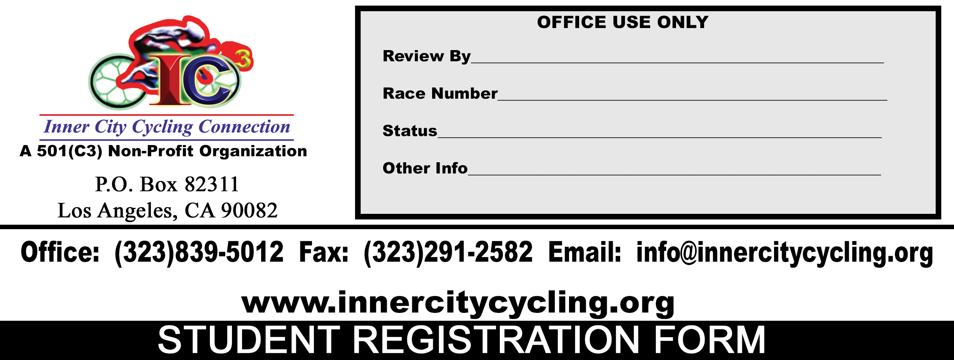

STUDENT INFORMATION (Please Print Clearly)
Student Name
 |  | Mr./Ms./Mrs. |  |  | First Name |  |  |  |  |  |  |  |  |  |  | M.I. |  | Last Name
Mailing Address
 |  | Address |  |  |  |  |  |  |  |  | Street |  |  |  |  |  |  |  |  |  |  |  |  |  | Apt. #
 |  | City |  |  |  |  |  |  |  |  |  |  |  |  |  |  |  |  |  |  | State |  |  |  | Zip Code
Contact Information
 |  | ( ) -- |  |  |  |  |  |  |  |  |  |  | ( ) -- |  |  |  |  |  |  |  |  | ( ) --
 |  | Day Time Phone No. |  |  |  |  |  |  |  |  |  | Night Time Phone No. |  |  |  |  |  |  |  |  |  |  | Cell Phone No.
 |  | Fax No.: ( ) --
 |  | Email Address:
 |  | Student Birthday: |  |  |  |  |  |  |  |  |  |  |  | Student Grade
 |  | Student Sex: Male [ ] Female [ ]
Are there any medical conditions Inner City Cycling Connection, Inc. needs to be aware of?
NAME OF YOUR SCHOOL
SCHOOL ADDRESS
SCHOOL PHONE NUMBER
NAME OF PRINCIPAL
PRINCIPAL PHONE NUMBER

PRINCIPAL EMAIL ADDRESS
NAME OF ATHLETIC COACH
ATHLETIC COACH PHONE NUMBER

ATHLETHIC COACH EMAIL ADDRESS

STUDENT MOTHER INFORMATION (Please Print Clearly)

Mother Name

Address
Home Phone # |  |  |  |  |  |  |  |  |  |  | Work Phone # |  |  |  |  |  |  |  |  | Cell Phone #

Email Address

STUDENT FATHER INFORMATION (Please Print Clearly)

Father Name

Address
Home Phone # |  |  |  |  |  |  |  |  |  |  | Work Phone # |  |  |  |  |  |  |  |  | Cell Phone #

Email Address
EMERGENCY CONTACTS (Different From Parent(s)/Guardian)
Physician/Doctor Name: |  |  |  |  |  |  |  | Physician/Doctor Phone No: |  |  |  |  |  |  |  |  |  |  | Medical Issues:
Name: |  |  |  |  |  |  |  | Phone No: |  |  |  |  |  |  |  |  |  |  | Relationship:
Name: |  |  |  |  |  |  |  | Phone No: |  |  |  |  |  |  |  |  |  |  | Relationship:
Name: |  |  |  |  |  |  |  | Phone No: |  |  |  |  |  |  |  |  |  |  | Relationship:
EVENT THE STUDENT IS ENTERING
(Please place a check mark by the appropriate category or categories. Student can enter more than one)
CATAGORY |  |  |  | CHECK BOX |  |  | OTHER INFORMATION
Race Meet |  |  |  | [ ]
Hip Hop Sound Contest |  |  |  | [ ]
Futuristic Bicycle Drawing Contest |  |  |  | [ ]
Essay Contest |  |  |  | [ ]
Coolest Bicycle Contest |  |  |  | [ ]
QUESTIONAIRE
(Please take a moment and answer the questions below so that we can continuously improve on the quality of this event)
How did you hear about us?
Does the student have prior cycling experience? If so, how many years? And what type of bike?
Are there any professional cyclists in your family? |  |  |  |  |  |  |  |  | Yes [ ] No [ ]
What other contest you would like to see at this event?
Additional comment(s)

****NOTICE****

I ACKNOWLEDGE THAT BY SIGNING THIS DOCUMENT, I AM ASSUMING THE RISKS ASSOCIATED WITH CYCLING, AGREEING TO INDEMNIFY, NOT TO SUE AND RELEASE FROM LIABILITY INNER CITY CYCLING CONNECTION, INC., IT’S ASSOCIATIONS, ASSOCIATES, CORPORATION BOARD OF DIRECTORS, IT’S RESPECTIVE AGENTS, EMPLOYEES, VOLUNTEERS, MEMBERS, SPONSORS, PROMOTERS, AND AFFILIATES (COLLECTIVELY “RELEASEES”), AND THAT I AM GIVING UP SUBSTANTIAL LEGAL RIGHTS. THIS ENTRY BLANK AND RELEASE IS A CONTRACT WITH LEGAL AND BINDING CONSEQUENCES AND IT APPLIES TO ALL INNER CITY CYCLING CONNECTION, INC., ACTIVITIES REGARDLESS WHETHER OR NOT LISTED ABOVE. IN ADDITION, BY SIGNING THIS DOCUMENT I UNDERSTAND AND AGREE TO THE FACT THAT INNER CITY CYCLING CONNECTION, INC. AND ITS AFFLIATES (COLLECTIVELY “RELEASEES”) ARE IN NO WAY LIABLE FOR ANY INJURIES SUSTAINED OR LOSS OF PROPERTY DURING PARTICIPATION IN ANY OF OUR EVENTS..

IN ADDITION, BY SIGNING THIS CONTRACT/REGISTRATION FORM, I AM AGREEING TO ALL TERMS AND CONDITIONS SET FORTH WITHIN.

- ___________ (MEDIA RELEASE) I give permission for photos, video footage, and voice of the student listed in this contract taken at INNER CITY CYCLING CONNECTION, INC. and it related functions to be used for all promotional purposes (website, twitter, facebook, instagram, magazine, flyers, posters, television, radio, etc.)

CONSENT AND RELEASE OF PARENT OR GUARDIAN

I am the parent of __________________________________________________________________________________ (child). My child is in excellent physical condition and is fit to register and participate in the INNER CITY CYCLING CONNECTION, INC. BICYCLE RACE MEET AND FESTIVAL. I HAVE READ AND UNDERSTAND THE ABOVE CONTRACT. In consideration of allowing my child to participate/register I shall consent to the contract and agree that ITS TERMS SHALL LIKEWISE BIND ME, MY CHILD, my heirs, legal representatives and assignees. I HEREBY RELEASE AND SHALL DEFEND, INDEMNIFY AND HOLD HARMLESS THE RELEASEES FROM EVERY CLAIM IN ANY LIABILITY that I or my child may allege against the RELEASEES (including reasonable fees and cost) of any injury WHETHER CAUSED BY THE NEGLIEGENCE OF THE RELEASEES on my behalf or on behalf of my child regarding any claim of rising from my child’s participation/registration in the BICYCLE RACE MEET AND FESTIVAL.

Signature of Parent or Guardian________________________________________________________________________Date__________________________

After filling the form out, please email it to info@innercitycycling.org or drop it off at a designated location.

I HAVE READ ALL THE TERMS AND CONDITIONS SET FORTH IN THIS CONTRACT AND UNDERSTANDS THEM FULLY

Signature of Student ____________________________________________________________AGE______________________DATE____________________

Signature of Parent/Guardian_____________________________________________________DATE______________________________________________

